CUMC Clean out the Closet – 2021 Outreach Project

Focus on Fostering Faithfully
Fostering Faithfully is a local faith-based non-profit organization that encourages and equips foster families and foster children. They seek to raise awareness about foster care and the need for foster families, and also provide support to children who are being transported by the Department of Social Services (DSS) in SC. Nationally, half of all foster families quit within a year after their first placement, and Fostering Faithfully hopes that their efforts will strengthen families to continue to provide the care and support that these children need. Fostering Faithfully focuses on families in Oconee and Pickens Counties through a support network of volunteers invested in nurturing foster children and their families. Their activities include foster family support groups, a meals ministry, date nights for foster parents, a resource/clothing center for local families, birthday parties for foster children, and providing car seats/cribs/equipment for foster families caring for babies and toddlers, and assisting with home repairs needed for foster care licensing.

How CUMC can help: CUMC provides financial support to Fostering Faithfully each year and some of our church members have been instrumental in volunteering to support local foster families via meal trains and community activities. This new Outreach Project will enable us to provide items that will immediately benefit children who are transitioning to a home with a foster family and will also assist foster families who are providing care and a safe home for these children.

Wish list items for Fostering Faithfully:
- Diapers/wipes/diaper cream/lotion
- Pull-up toddler training underwear (all sizes, especially larger sizes)
- New pajama sets for children (12 months to 5 years old)
- Summer swimsuits for boys and girls
- New teen clothing (S/M/L sizes)
- Teen hygiene kits and individual hygiene items (hair bands/brushes/toiletries/feminine products/lip balm) – will be shared with DSS to give to teens
- *Gift cards to fast-food restaurants (in small increments such as $5 and $10) – will be shared with DSS to give to children for meals during their transport to foster families.
- *Gift cards to Old Navy, Target, Walmart – will be given to teens coming into care
Donation options for Fostering Faithfully:
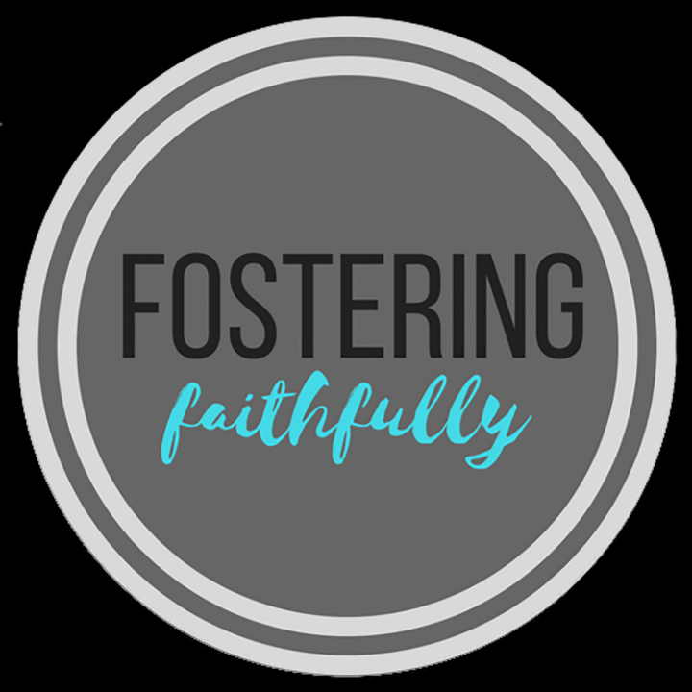
- Take to the local Fostering Faithfully collection site (large gray donation box with FF logo on it that is located on the side of the shopping center at Crosspoint Church in Clemson)
- Bring it to CUMC and place it in one of the marked boxes (CLC, office, or main sanctuary entry). Donations accepted between April 11 and April 28!

